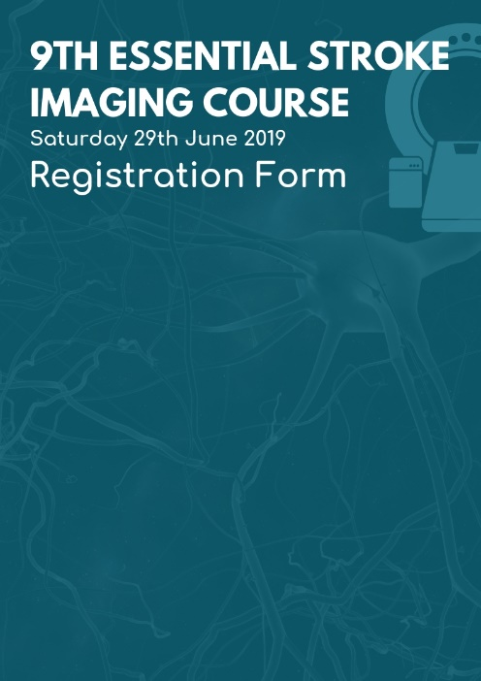

|  |  |  |  |  |  |
| --- | --- | --- | --- | --- | --- |
| **TITLE** | | **FIRST NAME** | | **INITIALS** | **LAST NAME** |
|  | |  | |  |  |
| **POSITION** | | |  | | |
| **HOSPITAL** | | |  | | |
| **TELEPHONE NUMBER** | | |  | | |
| **EMAIL ADDRESS** | | |  | | |
| **SPECIAL DIETS / ALLERGIES** | | |  | | |
| **PLEASE SELECT A PAYMENT METHOD:** | | | | | |
|  | **I ENCLOSE A CHEQUE MADE PAYABLE TO ‘ESSENTIAL COURSES’ IN THE SUM OF £150.00.** | | | | |
|  | **I WILL MAKE A BANK TRANSFER IN THE SUM OF £150.00**  **(PLEASE SEE COURSE INFO FOR INSTRUCTIONS)** | | | | |
|  | **I WILL TELEPHONE 0151 709 9125 x 2**  **TO MAKE PAYMENT VIA VISA / MASTERCARD / MAESTRO.** | | | | |
|  | **PLEASE TELEPHONE ME AT ___am / pm ON _________**  **TO COLLECT PAYMENT VIA VISA / MASTERCARD / MAESTRO.** | | | | |
|  | **PLEASE DEBIT MY CARD (VISA / MASTERCARD / MAESTRO)**  **FOR THE COURSE FEE OF £150.00 (COMPLETE DETAILS BELOW):** | | | | |
| **CARD NUMBER: _ _ _ _ _ _ _ _ _ _ _ _ _ _ _ _ EXPIRY DATE: _ _ / _ _**  **SECURITY CODE: _ _ _ SIGNATURE __________________** | | | | | |

**CONFIRMATION OF COURSE PLACES WILL ONLY BE MADE ON RECEIPT OF A COMPLETED REGISTRATION FORM AND PAYMENT.   
CANCELLATIONS MADE AFTER MAY 31st 2019 ARE TRANSFERABLE BUT NON-REFUNDABLE**

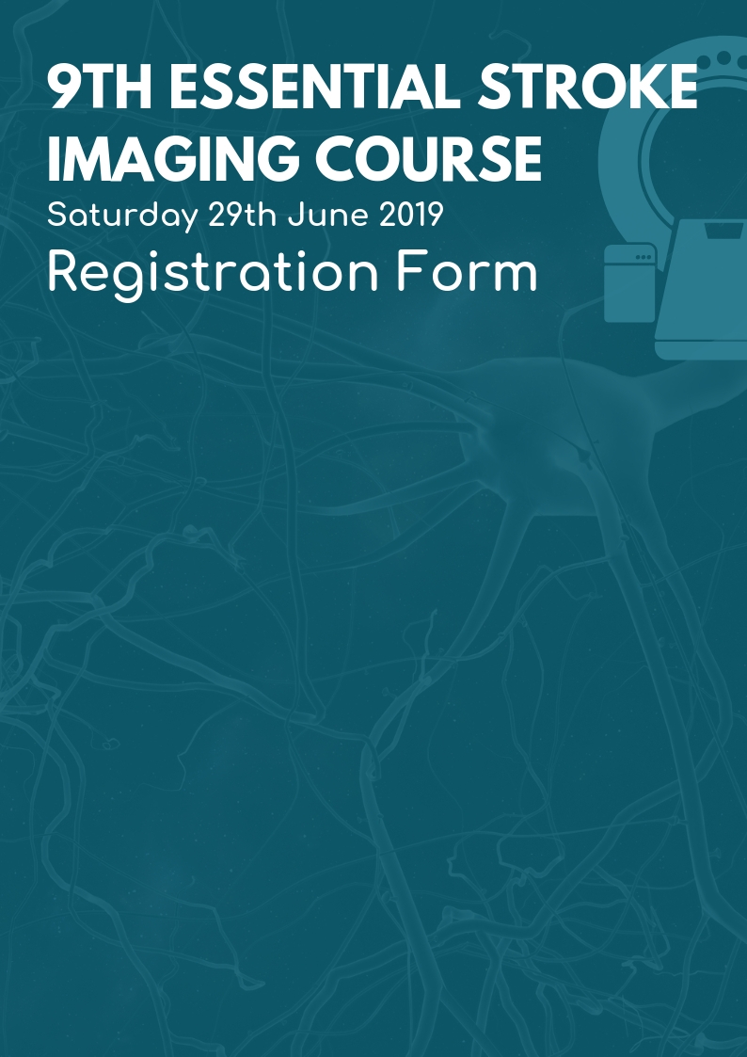

**Also available online at** <http://www.lmi.org.uk/esic>

|  |  |  |  |  |  |
| --- | --- | --- | --- | --- | --- |
| **TITLE** | | **FIRST NAME** | | **INITIALS** | **LAST NAME** |
|  | |  | |  |  |
| **POSITION** | | |  | | |
| **HOSPITAL** | | |  | | |
| **TELEPHONE NUMBER** | | |  | | |
| **EMAIL ADDRESS** | | |  | | |
| **SPECIAL DIETS / ALLERGIES** | | |  | | |
| **PLEASE SELECT A PAYMENT METHOD:** | | | | | |
|  | **I ENCLOSE A CHEQUE MADE PAYABLE TO ‘ESSENTIAL COURSES’ IN THE SUM OF £150.00.** | | | | |
|  | **I WILL MAKE A BANK TRANSFER IN THE SUM OF £150.00**  **(PLEASE SEE COURSE INFO FOR INSTRUCTIONS)** | | | | |
|  | **I WILL TELEPHONE 0151 709 9125 x 2**  **TO MAKE PAYMENT VIA VISA / MASTERCARD / MAESTRO.** | | | | |
|  | **PLEASE TELEPHONE ME AT ___am / pm ON _________**  **TO COLLECT PAYMENT VIA VISA / MASTERCARD / MAESTRO.** | | | | |
|  | **PLEASE DEBIT MY CARD (VISA / MASTERCARD / MAESTRO)**  **FOR THE COURSE FEE OF £150.00 (COMPLETE DETAILS BELOW):** | | | | |
| **CARD NUMBER: _ _ _ _ _ _ _ _ _ _ _ _ _ _ _ _ EXPIRY DATE: _ _ / _ _**  **SECURITY CODE: _ _ _ SIGNATURE __________________** | | | | | |

**CONFIRMATION OF COURSE PLACES WILL ONLY BE MADE ON RECEIPT OF A COMPLETED REGISTRATION FORM AND PAYMENT.   
CANCELLATIONS MADE AFTER MAY 31st 2019 ARE TRANSFERABLE BUT NON-REFUNDABLE**